
TOBB ETU
Economy & Technology University
BIL 495 / YAP 495

Software Design Description (SDD)
Reference: IEEE 1016-2009

Document Control Table
Document Title | Project Closure Report
Document ID | SDD-1.1-PAPILLON
Prepared By (Author) | Mete Cem Turan
Reviewed By
Approved By
Preparation Date | 30/11/2025
Approval Date
Version / Revision | 1.1
Confidentiality Level | Internal / Restricted / Public
Reference Standards | IEEE 15288, IEEE 12207, INCOSE SE Handbook v5

Change Record (Revision History Table)
Revision | Date | Prepared By | Reviewed/Approved By | Description of Change
1.0 | 18/11/2025 | Mete Cem Turan | (Approver) | Initial Release
1.1 | 30/11/2025 | Mete Cem Turan | (Approver) | Minor editorial updates
1.2 |  |  |  | Added stakeholder feedback section

1. Introduction
1.1 Purpose
1.2 Scope
1.3 References
2. System Overview
2.1 System Architecture
2.2 Design Rationale
3. Detailed Design
3.1 Component Descriptions
3.2 Interface Descriptions
3.3 Data Design
3.4 Algorithm Design
4. Traceability

1. Introduction
This Software Design Description (SDD) outlines the architectural structure and design principles of the SOC Analyst Cybersecurity Platform, a monolithic Django-based system that unifies essential security operations into a single interface. The platform enables security analysts to monitor their domains through features such as blacklist management, CVE tracking, attack-surface scanning, intrusion detection with AI-based anomaly analysis, phishing detection, cryptographic tools, and automated security reporting. Designed for users with technical expertise in IT or cybersecurity, the system integrates external APIs, data processing pipelines, and secure authentication mechanisms to provide an efficient, scalable, and reliable environment for continuous security monitoring and threat analysis.

1.1 Purpose
The purpose of this Software Design Description is to formally present the design-level details of the SOC Analyst Cybersecurity Platform, including its architectural structure, subsystem decomposition, data models, internal workflows, and component interactions. This document does not focus on implementation or user-level behavior; instead, it explains how the system is engineered, why specific design decisions were made, and how the underlying modules are structured to meet the platform’s functional and security requirements.

1.2 Scope
This Software Design Description covers the design details of all major subsystems within the SOC Analyst Cybersecurity Platform, including the Blacklist Management module, CVE Tracking and Vulnerability Feed Parser, Attack Surface Scanner, Email Leakage and Harvester Tools, Attack Simulation subsystem, Intrusion Detection System (IDS) with AI-based anomaly detection, Phishing Detection module integrated with user email accounts, PDF Security Reporting component, Cryptography utilities, and the authentication layer featuring 2FA and session management. The document focuses on the internal architecture, data structures, workflow logic, and interactions between these modules, providing a complete view of how each subsystem contributes to the overall platform.

1.3 References
IEEE_SRS 2.0
Software Architecture

2. System Overview

2.1 System Architecture
IEEE_SAD v1.0
The system follows a monolithic, layered architecture in which all core functionalities such as blacklist management, vulnerability tracking, attack-surface analysis, phishing detection, intrusion monitoring, malware analysis, and reporting operate within a unified Django application. The architecture is organized into clear layers, including the presentation layer (web UI and dashboard), the application/API layer (Django REST endpoints and authentication), the service layer (security analysis modules, CVE processing, ML orchestration, and simulation logic), and the data layer (MySQL database and storage services). Heavy or asynchronous operations, such as CVE fetching, IDS normalization, ML inference, and PDF generation, are handled through an integrated message-queue–based worker system to improve responsiveness. This design ensures modular organization within a monolithic structure, enabling maintainability, scalability, and consistent communication between subsystems.

2.2 Design Rationale
The system architecture is shaped by a combination of SRS constraints, performance targets, security requirements, and the practical limits of an academic prototype.
- Monolithic layered architecture with an event-driven sub-system.
The SRS explicitly constrains the solution to a monolithic web application built with Django and MySQL, to keep deployment and course grading simpler while ensuring all modules remain within a single codebase. At the same time, several use cases—such as IDS log ingestion, CVE fetching, malware analysis, and phishing detection—are naturally asynchronous and compute-intensive. To reconcile these needs, the design adopts a layered monolith (presentation, API, service, data layers) combined with an event-driven sub-system based on a message queue and background workers. This hybrid approach preserves the operational simplicity of a monolith while allowing independent scaling and decoupling of heavy background tasks. The trade-off is additional complexity in deployment (message broker, workers) compared to a pure monolith, but it avoids the even higher complexity of a full microservices architecture, which would be hard to justify within course time and budget.
- Message queue and worker pool for asynchronous processing.
A central design choice is to decouple ingestion from processing using a message queue and worker pool (e.g., Celery with Redis/RabbitMQ). IDS alerts, uploaded malware samples, phishing emails, and scheduled CVE updates are first persisted and placed onto a queue; specialized workers then process these jobs asynchronously. This allows the web UI to remain responsive even under load and supports scaling workers horizontally to meet performance requirements such as “IDS alert to dashboard under 2 seconds” and “malware analysis p95 ≤ 5 seconds.” The trade-off is that developers must handle eventual consistency, retries, and monitoring of queue depth, but the gain is predictable performance and resilience for long-running ML and sandbox operations.
- Isolated sandbox environments for malware and simulation tasks.
Any feature that executes or analyzes untrusted artefacts—such as malware samples or Caldera attack simulations—runs inside sandboxed VMs or containers on isolated network segments. This significantly reduces the risk of malware escaping into the host environment, protects other services, and aligns with security best practices and institutional policies. The trade-off is that sandboxing consumes more resources (CPU, RAM, possibly GPU) and adds overhead for provisioning and teardown of environments, but this is acceptable given the high security sensitivity of these operations.
- RBAC with mandatory 2FA for privileged users.
The system adopts role-based access control (Admin, Analyst, ReadOnly) as defined in the SRS functional requirements (FR10). Admins can view and manage all analysts and their configurations, while analysts operate on their own domains and data. To mitigate insider threats and unauthorized use of powerful functions such as attack simulation and configuration changes, the architecture enforces TOTP-based 2FA (RFC 6238) for admin accounts. This decision supports security, compliance, and auditability, at the cost of a slightly higher friction in the login flow for admins. For regular analysts, 2FA can be optional or configurable to balance usability and risk.
- Use of KMS for secret and key management.
Encryption keys, API tokens, and other sensitive configuration values are not stored in plain configuration files; instead, the design recommends using a Key Management Service (KMS) or Vault-like component. This aligns with ISO/IEC 27001 and NVD/OWASP best practices referenced in the SAD. The trade-off is the need to integrate an additional infrastructure component and manage its credentials, but it significantly reduces the risk of key leakage and supports clean key rotation procedures.
- Hardware and deployment choices for an academic prototype.
The SAD defines a prototype deployment model where the app server, database, message queue, GPU node, object storage, and sandbox VMs may initially be co-hosted or minimally separated, with recommendations for more production-like separation later. This choice acknowledges the limited budget and resources (C-09) while still providing a realistic architecture that can later be decomposed or scaled out. The trade-off is that the prototype may not fully match a hardened production environment, but the logical separation in the design ensures an upgrade path without major redesign.

3. Detailed Design

3.1 Component Descriptions

Authentication & Authorization Component
Handles user registration, login, session management, role-based access control (RBAC), and Two-Factor Authentication (2FA). Ensures secure access to all platform features and enforces permission boundaries for Admin, Analyst, and Read-Only roles.
2FA Enforcement Layer: Handles Time-based One-Time Password (TOTP) verification, recovery mechanisms, and rate limits authentication attempts. Required for administrative test criteria and system compliance with secure access policies

User Management Component
Manages analyst and admin accounts, domain ownership records, mailbox integrations, and user-level configuration settings. Provides interfaces for updating profile details and managing connected assets.

Blacklist Management Component
Stores and manages blacklisted IP/CIDR entries. Supports creation, deletion, modification, and lookup of blocked IPs. Provides validation, searching, and automated enrichment using external threat-intelligence APIs.

CVE Tracking & Vulnerability Feed Component
Fetches data from NVD/ExploitDB APIs, normalizes vulnerability entries, computes CVSS scores, and matches findings with user-owned assets. Maintains an up-to-date vulnerability database for dashboard visualization.
CVE Fetcher: Fetches vulnerability feeds from NVD, ExploitDB, or vendor advisories, converts them into platform-compatible records, and queues them for normalization.
Asset Matching Engine: Maps vulnerabilities to user-owned assets by comparing metadata such as domain name, software versions, and service signatures. Generates vulnerability relationships and dashboard indicators.

Attack Surface Analysis Component
Performs domain and subdomain enumeration, DNS analysis, SSL certificate inspection, port scanning, and exposure assessment. Generates risk scores for each domain and stores periodic snapshots.

IDS Ingestion & Normalization Component
Receives logs from IDS sources, normalizes them into a unified internal schema, and pushes processed alerts to the database and real-time dashboard. Runs through asynchronous workers to ensure high throughput.
API Collector: The API Collector acts as the trusted entry point for external security event sources such as IDS devices, mailbox forwarders, and monitoring agents. It exposes secured webhook endpoints that authenticate incoming requests, validate event schemas, and prevent malformed or malicious traffic from entering the system. Valid requests are converted into canonical event objects and dispatched to the Message Queue for asynchronous execution.
Normalizer Worker: The Normalizer Worker consumes events from the queue and harmonizes vendor-specific alert formats into a unified schema. It normalizes timestamps, source/destination tuples, protocol metadata, threat signatures, and severity scoring. Normalized alerts are persisted into the alert store and forwarded to the dashboard via real-time push channels.

Anomaly Detection & ML Analysis Component
Executes AI-based anomaly detection on incoming network traffic or IDS logs. Loads trained ML models, performs inference, computes risk metrics, and attaches explanations to alerts when applicable.
Inference Worker: The Inference Worker runs ML-based threat analysis on normalized IDS alerts. It loads pre-trained models, performs feature extraction, executes inference, and attaches prediction metadata such as confidence scores and anomaly classes. Results are returned to the event pipeline and exposed through dashboard notifications.
ML Orchestrator: The ML Orchestrator manages model lifecycle operations including model load, version control, runtime switching, and inference routing. It ensures the system can safely update or replace ML models without redeploying the entire platform.

Phishing Detection Component
Connects to the user’s mailbox via OAuth, retrieves incoming emails, extracts features, and runs them through phishing classification models. Flags suspicious messages and displays results in the platform.

Email Leakage / Harvester Component
Checks if user-associated email addresses or domain-related accounts appear in breach databases or online leaks. Provides search tools and automated scans to verify credential exposure.

Malware Analysis Component
Processes uploaded files in isolated sandbox environments, extracts PE features, and performs malware family classification using machine learning. Stores detailed analysis reports and classification results.
Sandbox Manager: The Sandbox Manager provisions isolated analysis environments (VM or container), executes malware binaries, monitors behavioral indicators, and extracts PE features. It ensures no network leakage, controlled execution, and safe teardown of analysis environments.

Attack Simulation Component
Orchestrates cyberattack scenarios such as DoS, brute-force, or reconnaissance using CALDERA or similar engines. Executes scenarios inside isolated VMs and collects telemetry to generate security evaluation outputs.

Reporting & PDF Generation Component
Compiles system data—alerts, vulnerabilities, domain scans, simulation results—into structured PDF reports. Converts HTML templates into downloadable reports for audits and compliance.

Cryptography Component
Provides encryption, decryption, hashing, and key-management utilities for the platform. Implements secure algorithms (e.g., AES-256-GCM, RSA-2048) and ensures proper key-handling practices.

Dashboard & Visualization Component
Generates real-time graphs, tables, and metrics using WebSockets and REST APIs. Displays IDS alerts, CVE trends, attack surface results, and ML outputs in an interactive UI.
WebSocket Gateway: The WebSocket Gateway delivers real-time notifications for alerts, ML results, and vulnerability updates. It maintains bidirectional client sessions, ensuring dashboards receive streaming updates without polling.

Message Queue / Worker Component
Handles asynchronous processing for heavy tasks such as CVE fetching, ML inference, phishing scans, malware analysis, and report generation. Ensures the web application remains responsive under load.
Worker Scheduler: Coordinates execution order, retry strategies, and timeout handling for queued jobs. Prevents overload, ensures fault-tolerance, and supports horizontal scaling.

Audit & Logging Component
Tracks user actions, admin operations, system events, and security-related activities. Maintains immutable logs for monitoring, debugging, and compliance requirements.

3.2 Interface Descriptions

Authentication & Authorization ↔ User Management
Input: Login credentials, 2FA codes, session tokens
Output: User identity object, role/permission set
Data Format: JSON, JWT/session token, TOTP code string
The authentication layer validates user credentials and provides a user identity object to the User Management component for role-based access enforcement.

User Management ↔ Blacklist Management
Input: User domain ID, analyst role metadata
Output: Authorized blacklist entries, CRUD results
Data Format: JSON
The User Management component sends user ownership and authorization data to the Blacklist module to ensure only permitted analysts modify blacklisted IPs.

CVE Tracking System ↔ Database / Dashboard
Input: Raw NVD/ExploitDB feed, normalized CVE records, CVSS scores
Output: Structured vulnerability objects, asset-matching results
Data Format: JSON, CVSS scoring objects
The CVE module normalizes feed data and stores structured vulnerability entries in the database, which the dashboard later queries.

Attack Surface Analyzer ↔ Domain Records
Input: Domain/subdomain metadata, scan configuration
Output: Port scan results, SSL certificate metadata, risk scores
Data Format: JSON, PEM (SSL certificates)
Scan results are sent to the dashboard and written to the database for time-series comparison.

IDS Ingestion Component ↔ Anomaly Detection
Input: Normalized IDS alerts, traffic feature vectors
Output: Anomaly classification, risk probability, metadata
Data Format: JSON alert schema, vectorized numerical feature arrays
The IDS component normalizes logs and passes them to the ML module for anomaly scoring.

Phishing Detection ↔ Mail Connector
Input: Raw email content, headers, attachment metadata
Output: Phishing likelihood score, flagged results
Data Format: MIME email structures, JSON classification output
The mail connector extracts messages and sends parsed features to the phishing classifier.

Malware Analysis ↔ Sandbox
Input: File hash, binary file reference, execution parameters
Output: Feature vectors, behavioral logs, malware family prediction
Data Format: Binary (file), JSON, text logs
Files are passed to an isolated environment, and results flow back to the analysis engine.

Attack Simulation ↔ Caldera Engine
Input: Scenario profile, domain target metadata
Output: Telemetry logs, simulation success/failure results.
Data Format: JSON, log streams
Simulation results are processed and stored for later reporting.

Reporting Component ↔ All Other Modules
Input: Alerts, vulnerabilities, user domains, simulation results
Output: PDF report
Data Format: JSON, HTML → PDF render
Reports aggregate data from multiple modules and format them into exportable documents.

Cryptography Component ↔ Application Services
Input: Plaintext strings, encryption keys, hash requests
Output: Ciphertext, hash digests, decrypted strings
Data Format: Base64, binary, UTF-8 strings
All encryption/decryption requests flow through this central interface.

Message Queue ↔ Background Workers
Input: Job objects (CVE fetch, ML inference, sandbox tasks, scans)
Output: Completed task payloads, status messages
Data Format: Serialized JSON job messages
Workers consume job messages and return results back to the application layer.

Dashboard ↔ API Layer
Input: API queries for vulnerabilities, alerts, blacklist, scans
Output: Metrics, time-series data, summaries
Data Format: JSON, WebSocket event streams
The dashboard receives real-time data updates via WebSockets and retrieves historical data via REST endpoints.

3.3 Data Design
The system’s data design is centered around a relational database schema implemented in MySQL, structured to support core cybersecurity operations such as asset management, vulnerability tracking, IDS alert processing, anomaly classification, phishing detection, malware analysis, and simulation logging. The schema follows a normalized, modular design in which each functional subsystem maintains its own primary tables, while shared entities such as users, domains, and audit logs serve as relational anchors across components.
In addition, the class diagram can be accessed via the file below:
Class Diagram.png

User and Access Control Data Structures
User: Stores core identity information, authentication credentials (hashed), 2FA configuration, and role assignments.
Fields: user_id (PK), email, password_hash, role, 2fa_secret, created_at, last_login
User_Domain: Represents ownership of domains by analysts.
Fields: id (PK), user_id (FK), domain_name, verified, created_at

Blacklist Data Structures
Blacklist_Entry: Stores IP or CIDR blocks flagged by the user or system feeds.
Fields: entry_id (PK), ip_or_cidr, reason, created_by (FK), created_at
Threat_Enrichment: Stores additional threat intelligence data (e.g., reputation, ASN, geolocation).
Fields: entry_id (FK), source, score, metadata

CVE and Vulnerability Tracking Structures
CVE_Record: Stores normalized CVE data pulled from NVD/ExploitDB.
Fields: cve_id (PK), description, cvss_score, published_date, severity
Asset_Vulnerability: Maps vulnerabilities to user-owned assets (domains, ports, services).
Fields: id (PK), domain_id (FK), cve_id (FK), affected_service, detection_date

Attack Surface Analysis Tables
Domain_Scan: Stores results of port scans, DNS evaluations, and SSL checks.
Fields: scan_id (PK), domain_id (FK), timestamp, open_ports (JSON), ssl_expiry, risk_score
Subdomain_Record: Enumerated subdomains discovered during scans.
Fields: id (PK), domain_id (FK), subdomain, ip, created_at

IDS Alert and Anomaly Detection Structures
IDS_Alert: Stores normalized IDS log entries.
Fields: alert_id (PK), domain_id (FK), raw_log (JSON), timestamp, source_ip, dest_ip, signature
Anomaly_Result: Stores ML classifier output for each alert.
Fields: id (PK), alert_id (FK), anomaly_score, classification_label, model_version

Phishing Detection Tables
Email_Message: Stores normalized email content retrieved from mailbox connectors.
Fields: message_id (PK), user_id (FK), subject, sender, raw_body, attachments (JSON), received_at
Phishing_Analysis: ML model output indicating likelihood of phishing.
Fields: id (PK), message_id (FK), probability, classification, features (JSON)

Malware Analysis Data Structures
File_Upload: Metadata for uploaded binaries.
Fields: file_id (PK), user_id (FK), filename, hash_sha256, storage_path, uploaded_at
Malware_Report: Stores extracted features, sandbox behaviors, and model predictions.
Fields: report_id (PK), file_id (FK), feature_vector (JSON), family_prediction, behavior_log (TEXT)

Attack Simulation Logging
Simulation_Run: Defines configuration and results of CALDERA-based simulations.
Fields: run_id (PK), user_id (FK), domain_id (FK), scenario, started_at, completed_at, status
Simulation_Telemetry: Collects logs and metrics during a simulation.
Fields: id (PK), run_id (FK), timestamp, event_type, details (JSON)

Reporting and Audit Structures
Security_Report: Stores metadata of downloadable PDF reports.
Fields: report_id (PK), user_id (FK), file_path, created_at
Audit_Log: Tracks system actions, admin operations, and security events.
Fields: id (PK), user_id (FK), action_type, timestamp, details (JSON)

System Task & Messaging Structures
Async_Task: Represents queued jobs processed by workers (ML inference, CVE fetch, scans).
Fields: task_id (PK), task_type, payload (JSON), status, created_at, completed_at

3.4 Algorithm Design
Diagrams
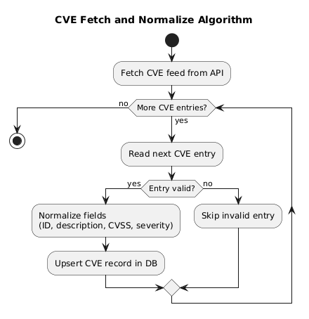
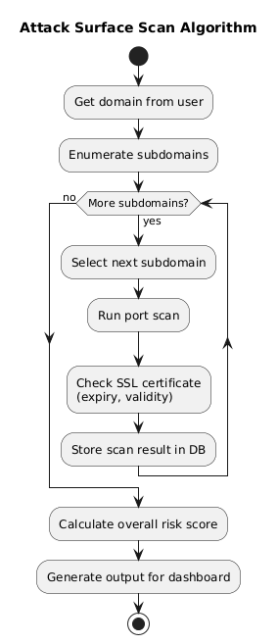
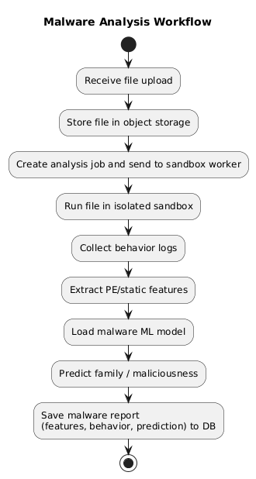
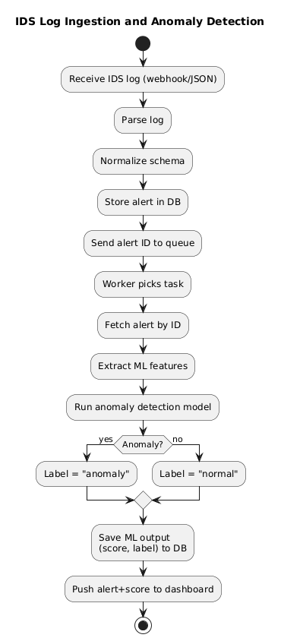

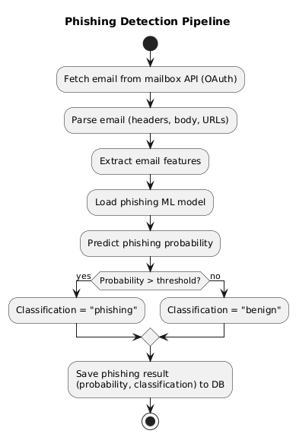

3.5 System Sequence Diagram
Sequence Diagram
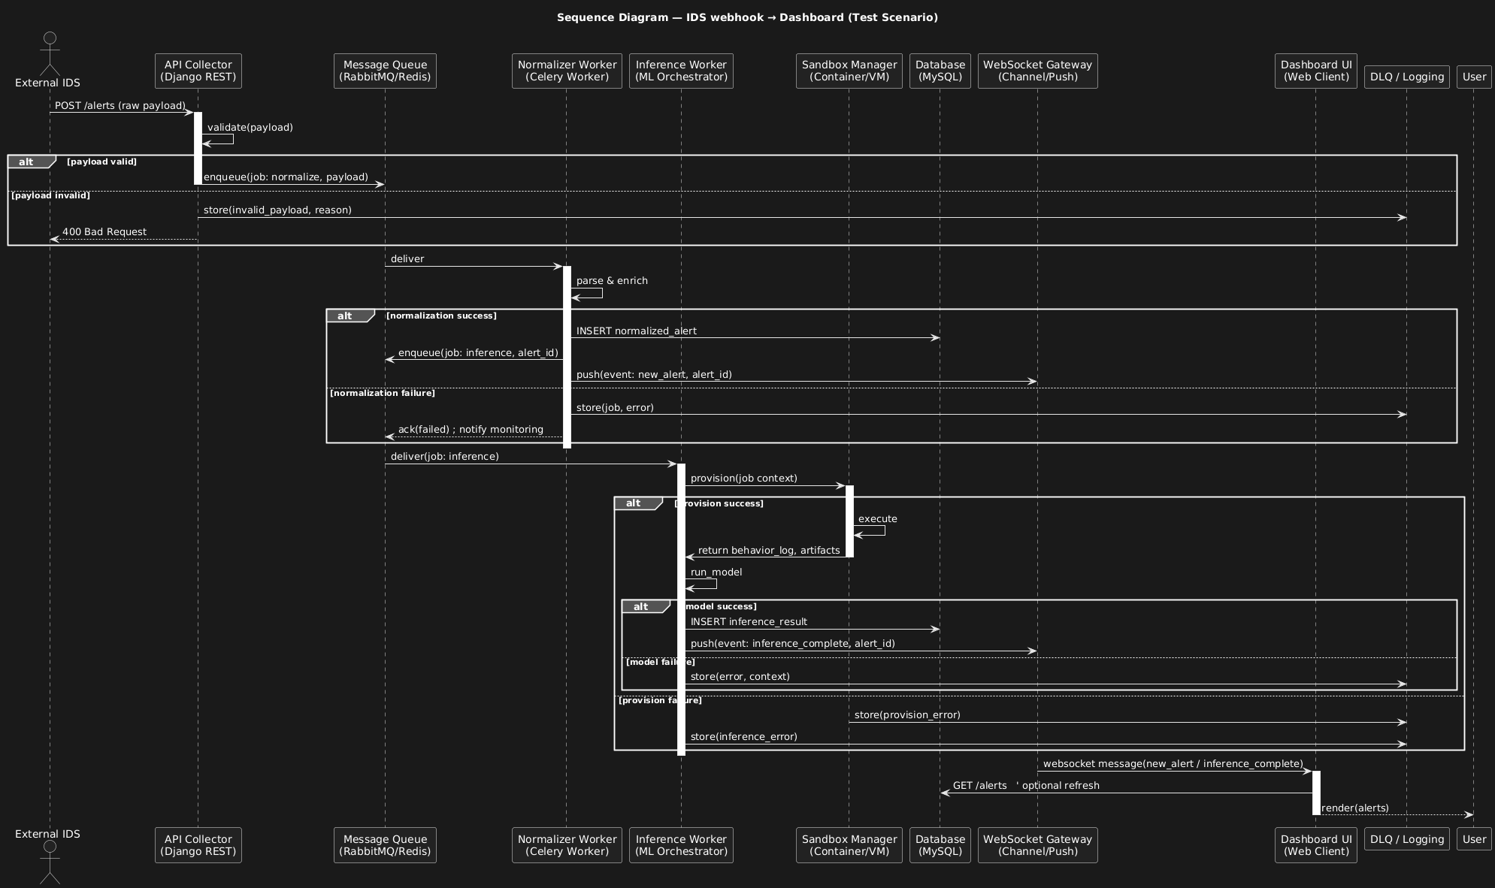

3.6 State Machine Diagrams
Machine Diagrams
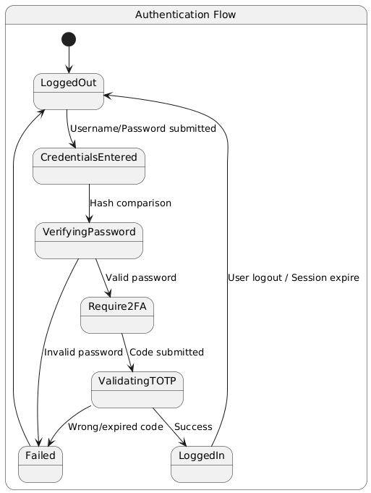
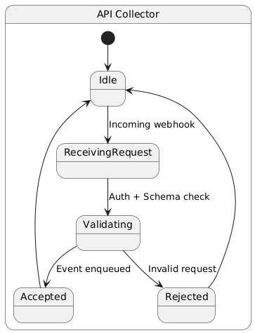

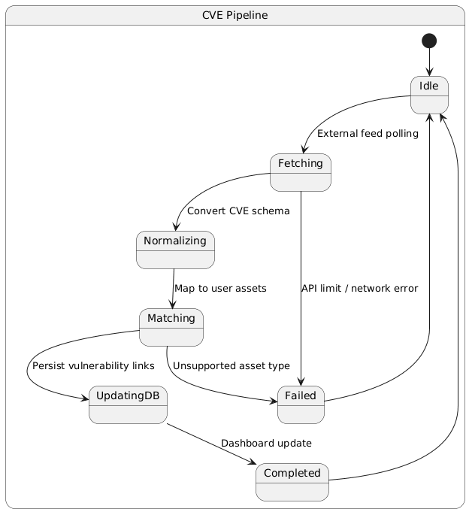
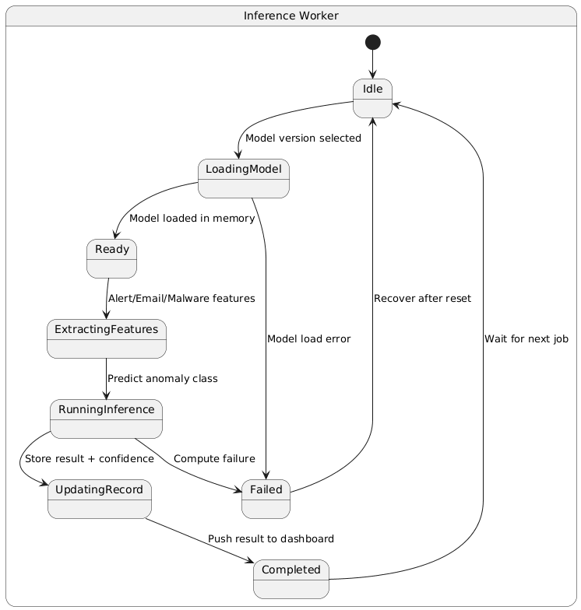



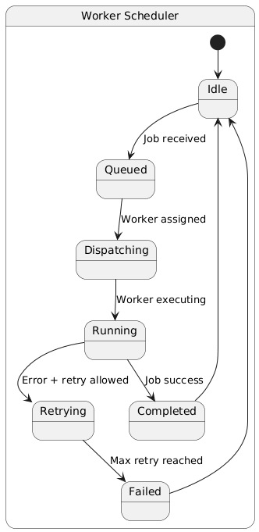
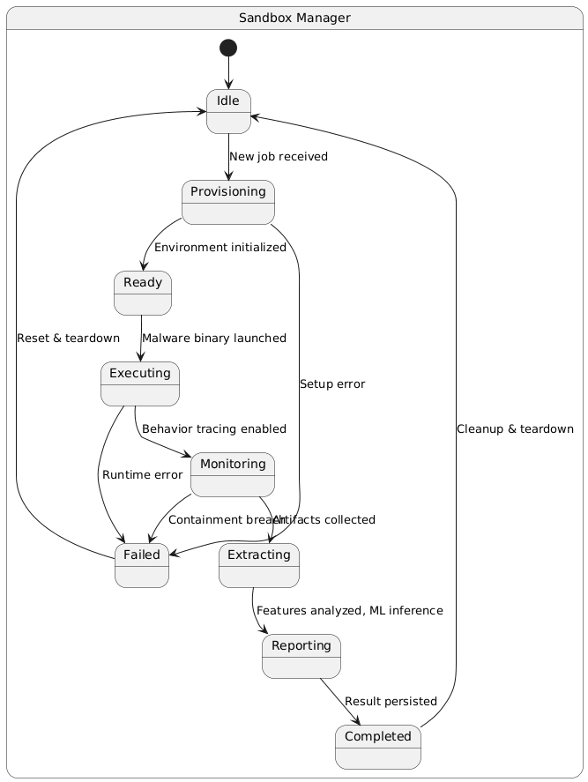

4. Traceability
Component-to-Requirement Traceability
SDD Component | Related SRS Requirements | Explanation
Authentication & Authorization | FR10, DT_FR10, NFR-Security | Implements user login, RBAC, 2FA, session TTL, and secure access control.
User Management | FR10, NFR-Usability | Manages analyst/admin accounts, domain ownership, mailbox tokens, and configuration data.
Blacklist Management | FR1, DT_FR1 | Supports adding/removing IP/CIDR entries, viewing blocked addresses, and automated enrichment.
CVE Tracking | FR2, DT_FR2 | Fetches NVD/ExploitDB data, normalizes CVEs, computes CVSS scores, and links vulnerabilities to domain assets.
Attack Surface Analysis | FR3, DT_FR3 | Performs DNS enumeration, port scanning, SSL checks, and builds exposure profiles for domains.
IDS Log Ingestion | FR4, DT_FR4 | Receives IDS logs, normalizes formats, stores structured alerts for further ML analysis.
Anomaly Detection | FR4, DT_FR4 | Runs ML model to detect anomalies and classify IDS events as normal or suspicious.
Phishing Detection | FR6, DT_FR6 | Connects to mailbox via OAuth, extracts email features, and classifies phishing risk.
Malware analysis | FR7, DT_FR | Executes binaries in a sandbox, extracts PE features, and predicts malware family.
Attack Simulation | FR8, DT_FR8 | Executes controlled cyberattack scenarios and collects telemetry in sandbox environments.
PDF Reporting Engine | FR9, DT_FR9 | Generates consolidated PDF reports covering CVEs, alerts, scans, and simulations.
Cryptography Module | FR10, NFR-Security | Provides secure AES-256/RSA encryption, hashing, and key-management functions.
Dashboard | FR1–FR9 | Displays results from all modules in real time using WebSocket updates.
Message Queue & Workers | NFR-Performance, NFR-Reliability | Enables asynchronous task execution for ML inference, sandboxing, and periodic scanning processes.
Audit & Logging | NFR-Security, NFR-Maintainability | Records all user actions and system events for compliance and forensic analysis.

5. Deployment Architecture
The system deployment consists of a container-orchestrated environment in which core services operate in isolated but interconnected execution units. The environment supports asynchronous workflows, GPU-accelerated inference, sandboxed malware execution, and real-time event streaming.

Component | Deployment Unit | Technology
Web backend | Docker | Python/Django
Message Queue | Docker | RabbitMQ/Redis
Worker Nodes | Docker Worker Container | Celery Workers
Sandbox | VM/Container | QEMU/Firecracker/Docker
Object Storage | Container | MinIO/S3
Dashboard | Web Client | WebSocket & Rest
Vulnerability DB | MySQL Container | MySQL Server

Deployment Diagram
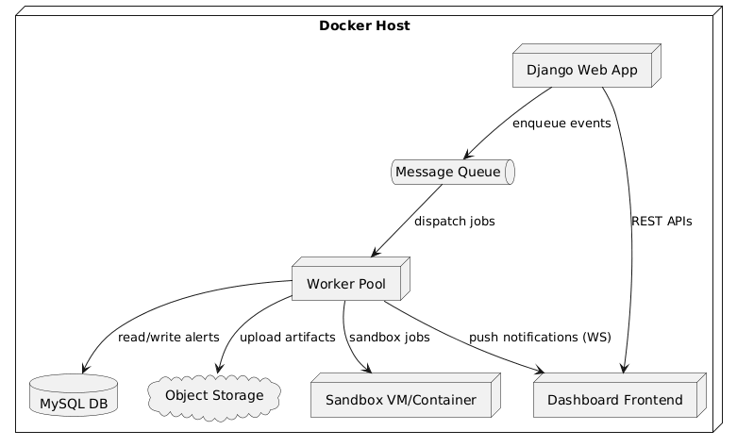

6. Appendix

A. Acronyms and Abbreviations
IDS: Intrusion Detection System
CVE: Common Vulnerabilities and Exposures
CVSS: Common Vulnerability Scoring System
TI: Threat Intelligence
IOC: Indicator of Compromise
DB: Database
RBAC: Role-Based Access Control
2FA: Two-Factor Authentication
NVD: National Vulnerability Database
AES: Advanced Encryption Standard
API: Application Programming Interface

7. References
- SRS (Software Requirements Specification) v2.0
- STP (Software Test Plan) v1.0
- SAD (System Architecture Document) v1.0
- Detailed Requirements — Delivered in Sprint 2 and Sprint 3
- PMP (Project Management Plan) v1.0
- Technical Analysis Report - Delivered in Sprint 3

